

Mobivue PMMS

Ajanta Pharma Ltd.

Functional Specification Document (WMS)

This document includes the functional and non- functional requirements for specification of the application designed for Ajanta Pharma.

BAR CODE INDIA, 145 Udyog Vihar Phase 1, Gurugram, Haryana-122016, PH: 0124 4337555 1

Prepared By: Leena
Version Number: 1.0
BAR CODE INDIA, 691 UDYOG VIHAR PHASE V, GURUGRAM, HARYANA - 122016, Ph.: 0124 4337555

Inward

Gate Entry
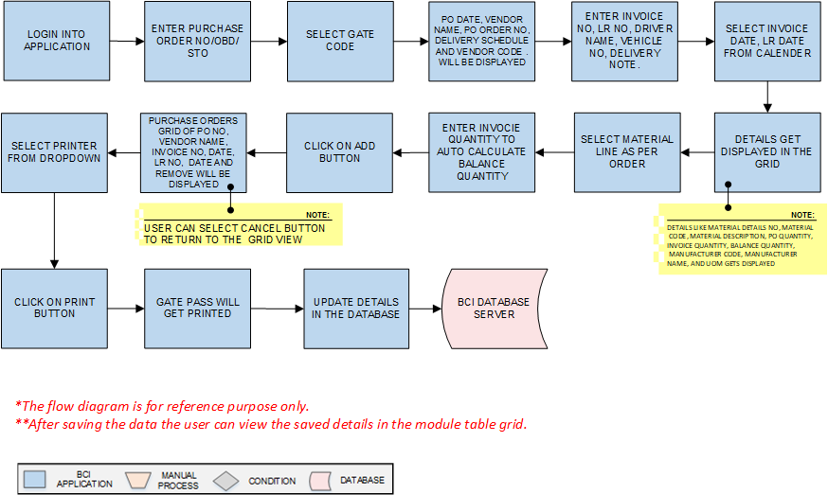
Activities
Module Description | Gate Pass activities controls and manage the material vehicle movement inside the plant for unloading the material.

Pre-Conditions | - Purchase Order No/ OBD/STO details should pushed from SAP to BCI system.

Process Steps | - User will login into Application.  - Enter Purchase Order No/ OBD/STO.  - Select Gate Code from dropdown  - PO Date, Vendor Name, PO Order No Delivery Schedule and Vendor Code will be displayed  - Enter Invoice No, LR No, Driver Name, Vehicle No, Delivery note  - Select Transporter Name.  - Select Invoice Date, LR Date from the calendar.  - A grid format of Material details No, Material Code, Material Description, PO Quantity, Invoice Quantity, Balance Quantity, Manufacturer Code, Manufacturer Name, and UOM will displayed on the screen  - Select the material lines as per received material and enter the invoice quantity system will auto calculate the balance quantity  - Click on Add button.  - Purchase Orders Grid of PO No, Vendor Name, Invoice No, Invoice Date, LR No, LR Date, and Remove will appear on the screen.  - By selecting the cancel button user can return to the grid view without saving any data.  - Select printer from dropdown.  - Click on Print button.  - Gate Pass will get printed.  - Update the details in the database in grid view.  - The grid view is as Created date, Gate entry no , Purchase order no/OBD/STO,LR No., Done By, Status and action  - Status column will show the status of the gate entry i.e. active/in-active  - Selecting the action button user can display details of the gate entry  *Authorized user can edit, view, cancel, re-print and back the screen as per requirement by entering appropriate remark.  System will not allow the cancel gate entry to proceed the next step and the cancel gate entry invoice quantity will be added back to the balance quantity

Post-Conditions | - Gate Pass barcode label should be available at the unloading bay.

Validations | - An alert should be displayed in case duplicate/ invalid Purchase Order No is entered.  - An alert should be displayed in case duplicate Invoice No is entered.  - An alert should be displayed in case Purchase Order details are not fetched from SAP.

Vehicle Inspection
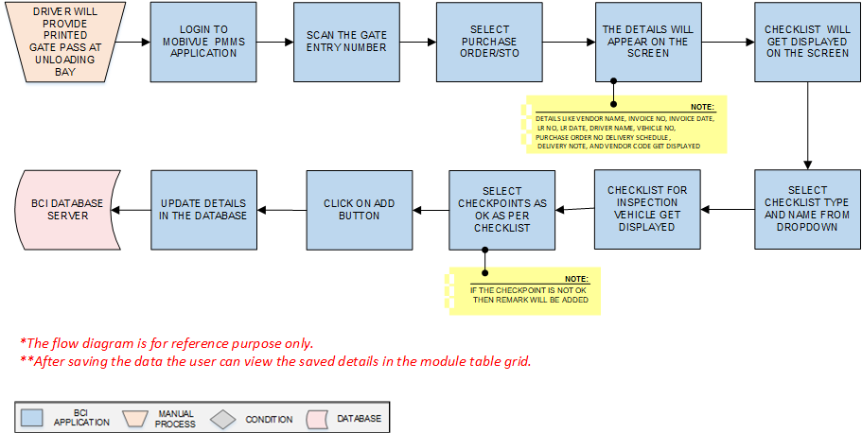
Activities
Module Description | Before unloading material from the vehicle, vehicle will be inspected against the defined checklist.

Pre-Conditions | - Printed Gate Pass should be available.  - Checklist should available in Checklist master.

Process Steps | - Driver will provide printed Gate Pass at the unloading bay Gate entry.  - User will login in Pharmision application MobiVue PMMS system.  - Scan the Gate Entry No Number .  - Select Purchase Order/STO.  - Details such as Vendor Name, Invoice No, Invoice Date, LR No, LR Date, Driver Name, Vehicle No, Purchase Order No Delivery Schedule, Delivery Note, and Vendor Code (as applicable) will appear on the screen.  - Enter the remark as applicable.  - Select checklist Type as required from dropdown.  - Select checklist Name as required from dropdown.  - Checklist for inspection of vehicle will appear on the screen.  - Update the checklist as per the observation.  - Click on Add button.  - Inspection will be completed.  - Update the details in the database details will display in the grid.  - Grid view as Created date, Gate entry no., Purchase order STO, Invoice no., Invoice date, done by, status and action.  - Under status column status of the process will be display.  - By selecting the action details of the entry will be display.  - Selecting the back/cancel button user can return to the main grid screen from the particular screen without any change.  - In case any non-conformance observed in the checklist the status will be display as on-hold and system will not allow to proceed next step.  - If authorized user after selecting the action, accept the entry then it will allow to proceed next step.  *Authorized user can edit, view, hold, accept and reject after entering appropriate remark.

Post-Conditions | - Vehicle inspection will be completed.

Validations | - An alert should be displayed in case invalid Gate Entry No is scanned.  - An alert should be displayed in case duplicate/ invalid Purchase Order is selected.

Material Inspection
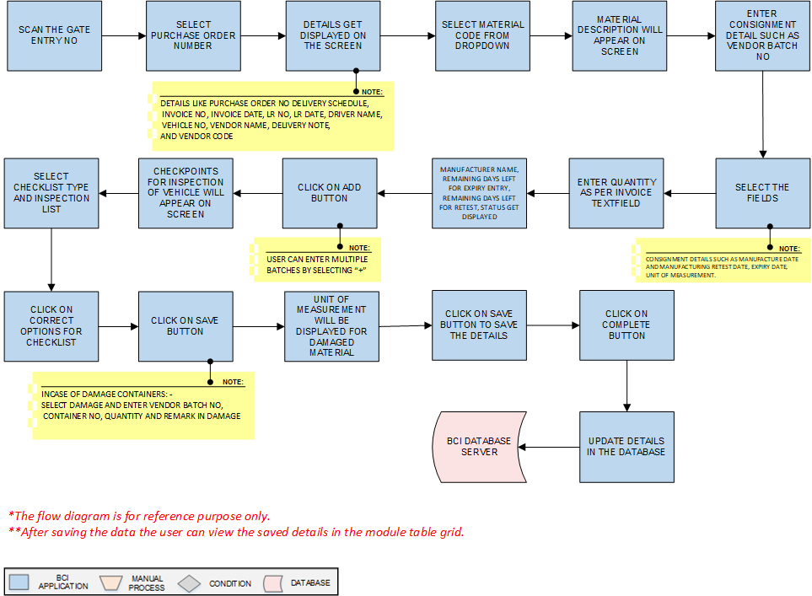
Activities
Module Description | In this module material is inspected after the material has received at the plant, mostly from outside plant (from Vendor, other plants etc.)

Pre-Conditions | - Gate Pass should be available for scanning.  - Vehicle Inspection should be completed.

Process Steps | - Scan the Gate Entry No.  - Select Purchase Order from dropdown.  - Details such as Purchase Order No Delivery Schedule, Invoice No, Invoice Date, LR No, LR Date, Driver Name, Vehicle No, Vendor Name, Delivery Note, and Vendor Code (as applicable) will appear on the screen.  - Select Material Code from dropdown for Material details.  - Material Description will appear on the screen.  - Enter Consignment Details such as Vendor Batch No.  - User will select Consignment details such as Manufacture Date and Manufacturing Retest Date, Expiry Date, Unit of Measurement.  - Enter Quantity as per Invoice, Text Filled  - Manufacturer Name, Remaining days left for expiry entry, remaining days left for Retest, Status will displayed on screen.  - Click on add button to save Consignment details  - User can enter multiple batches by selecting “+” sign  - Checkpoints for Material inspection will appear on the screen.  - Select Checklist Type and Inspection Checklist for checkpoints from dropdown.  - Click on correct options for checklist add remark if user is not satisfactory.  - Click on Save button to save the checkpoint details.  - EnterSelect damage In case of damage containers: - Select damage and enter Vendor Batch No, Container No, Quantity and Remark in Damage section if the material is damaged.  - Unit of measurement will be displayed for the damaged material.  - Click on save button to save the details.  - Click on Complete button to complete the process.  - Update the details in database and display in grid view  - Grid view display as Created date, Gate entry no., Purchase order STO, Invoice no., Invoice date, Material code, Material name, done by, status and action.  - Under status column status of the process will be display.  - By selecting the action details of the entry will be display.  - Selecting the back/cancel button user can return to the main grid screen from the particular screen without any change.  - In case any non-conformance observed in the checklist the status will be display as on-hold and system will not allow to proceed next step.  - If authorized user after selecting the action, accept the entry then it will allow to proceed next step.  - *Authorized user can edit, view, hold, accept and reject after entering appropriate remark.

Post-Conditions | - Material inspection will be completed.

Validations | - An alert should be displayed in case invalid Gate Entry No is scanned.  - An alert should be displayed in case duplicate/ invalid Purchase Order is selected.  - .

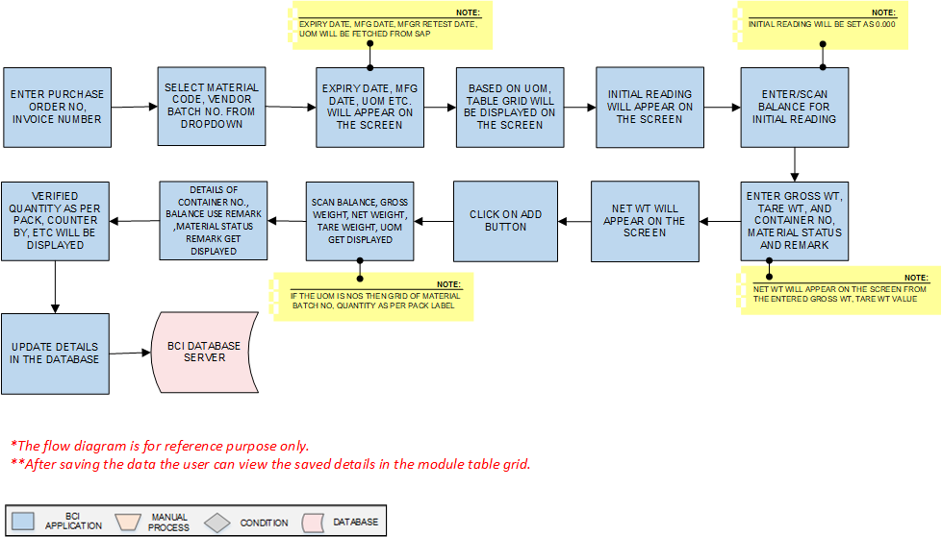
Weight Quantity/Verification

Activities
Module Description | In this module, the Weight/Quantity verification of the material will be carried out

Pre-Conditions | - Material Inspection should be completed.  - Calibrated Weighing Balance master should be available.(If applicable )

Process Steps | - Enter Purchase Order No, Invoice Number.  - Select Material Code, Vendor Batch No. from dropdown.  - Expiry Date, Mfg. Date, Mfg. Retest Date, UOM of the selected material will appear on the screen.  - Based on UOM, table grid will be displayed on the screen.  - In case of UOM in KG: - Enter/Scan Balance for Initial reading.  - Initial reading will appear on the screen.  - Enter/Scan balance Id.  - Enter Gross Wt, weight, Tare Weight, and Container No, Material Status Remark.  *Net Weight will appear on the screen from the entered Gross Weight, Tare Weight value.  - Net weight will appear on the screen.  - Click on Add button.  - Grid of balances (if the UOM KG) such as Scan Balance, Gross weight, Net weight, Tare weight, UOM, Container No., Balance use remark ,Material Status Remark and action will appear on the screen.  - If the UOM is NOS then grid of Material Batch No, quantity as per pack label.  - Verified quantity as per pack, Counter by, Remark will appear on the screen.  - Details will get saved in database and display in grid view.  - Grid view as Created date, Gate entry no., Purchase order/ STO, Invoice no., Material code, Material name, Vendor batch no. done by and action.  - User will be able to delete the entry details after click on the delete button and entering the remark  - Clicking on the back button user will back to the grid view  - Authorized user can able to add the data by selecting the edit button.

Post-Conditions | - Weight/Quantity verification Capture details get in displayed.

Validations | - An alert should be displayed in case duplicate/invalid Purchase Order is entered.  - An alert should be displayed in case duplicate/invalid Invoice Number is selected.  - An alert should be displayed in case of Initial reading will not set to zero (There will be no alert message incase offline balance use).

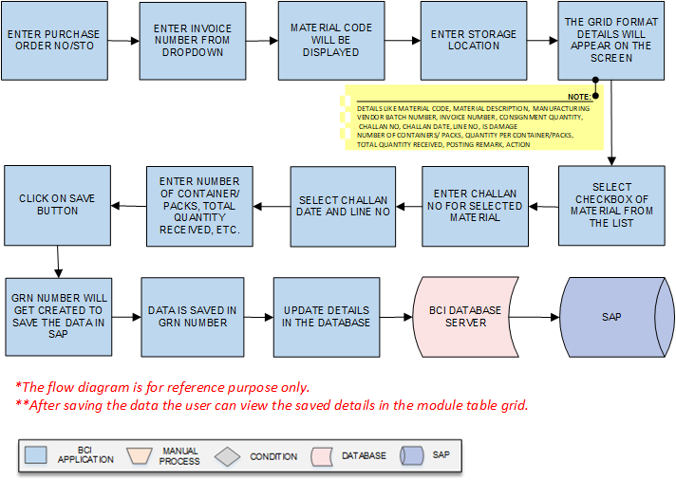
GRN Posting
Activities
Module Description | In this module the inspected data of Material, Weight Capture details are submitted to SAP.

Pre-Conditions | - Weighing Balance master should be available. Weight /Quantity verification of the materials should be completed

Process Steps | - Enter Purchase Order /STO.  - Enter Invoice Number  - Select Material code will be displayed.  - Enter Storage Location.  - After selection of the material a grid format of Grid format of Material Code, Material Description, Manufacturing Vendor Batch Number, Invoice Number, Consignment Quantity, Challan No, Challan Date, Line No, Is Damage, Number of Containers/ Packs, Quantity per Container/Packs, Total Quantity Received, Posting Remark, Action will appear on the screen.  - Select checkbox of Material from the list.  - Enter Challan No for selected Material.  - Select Challan Date from calendar and Line No from dropdown for selected Material.  - Enter Number of Container/Packs, Quantity per Container/Packs, Total Quantity Received, Posting Remark.  - Click on save button.  - GRN number will get created to save the data in SAP.  - Details will get saved in database and display in grid view.  - The grid view as GRN NO, GRN Date, Purchase order/STO, Material code, Material Name, Invoice No, Invoice date, done by and action.  - By selecting the action details of the entry will be display.  - Selecting the back/cancel button user can return to the main grid screen from the particular screen without any change.

Post-Conditions | - Material and Weight capture details will maintained in SAP against the GRN number.  - GRN no & SAP batch no will be receive from SAP

Validations | - An alert should be displayed in case duplicate/ invalid Purchase Order is selected.  - An alert should be displayed in case duplicate/ invalid Invoice Number is selected.  - An alert should be displayed in case of GRN number is not created.

Material Label Printing
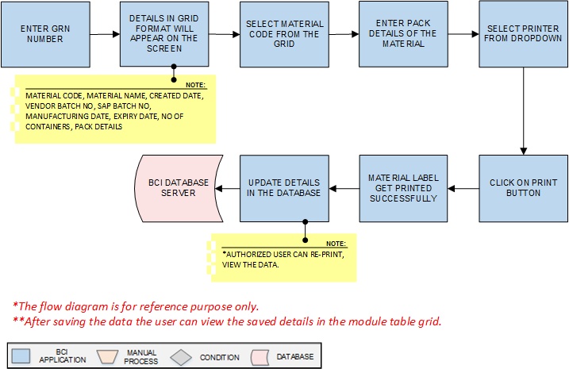
Activities
Module Description | The Module will be used to print material label for each container against GRN material details.

Pre-Conditions | - Material data should be saved in GRN number.  - Material Inspection needs to be completed.

Process Steps | - Enter GRN number.  - A grid format of Material Code, Material Name, Created Date, Vendor Batch No, SAP Batch No, Manufacturing Date, Expiry Date, No of Containers, Pack details, Done By will appear on the screen.  - Select checkbox of Material Code from the list.  - Enter Pack Details of the material.  - Select printer from dropdown.  - Click on Print button.  - Material label get printed successfully.  - Data is saved in database.  *Authorized user can re-print, view the data.

Post-Conditions | - Material Label get printed.

Validations | - An alert should be displayed in case duplicate/ invalid GRN number is entered.  - An alert should be displayed in case duplicate/ invalid Pack Details are entered.

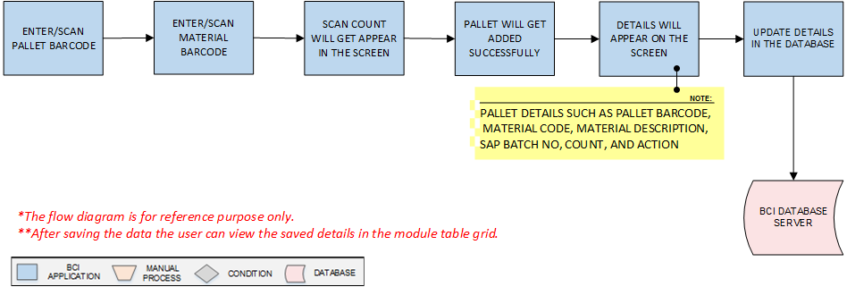
Palletization
Activities
Module Description | This module will be used to map pallet and material containers placed on pallet.

Pre-Conditions | - Printed labels are applied on each container.  - Pallet should have valid barcode.

Process Steps | - Enter/Scan Pallet Barcode.  - Enter/Scan Material Barcode.  - Scan count will get appear in the screen.  - Pallet will get added successfully.  - A grid format of Pallet details such as Pallet Barcode, Material Code, Material Description, SAP Batch No, Count, and Action will appear on the screen.  - Data is saved in database and display in grid.  - Grid view display as Created date, Pallet bar code, Material code, Material Name, SAP Batch No, No of Container, Done by and action.

Post-Conditions | - Pallet details are saved in database.  - Pallets are moved for Put away in warehouse.

Validations | - An alert should be displayed in case duplicate/ invalid Pallet Barcode is entered.  - An alert should be displayed in case duplicate/ invalid Material Barcode is entered.

Put Away
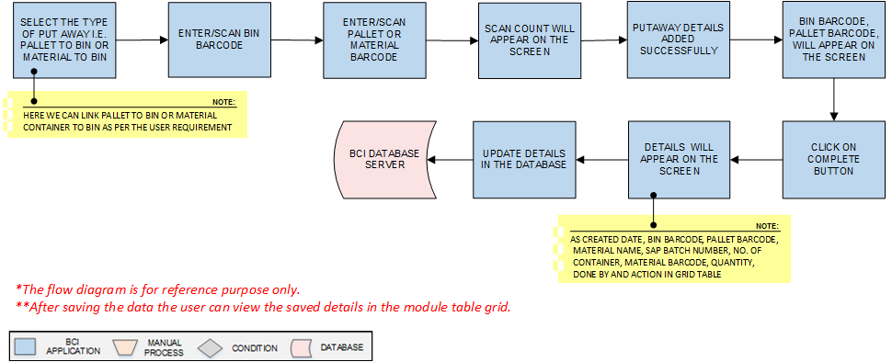
Activities
Module Description | This module will be used to map Pallets to Bins and Material to Bins.

Pre-Conditions | 1. In case of the Material to bin all the containers should contain bar code label  2.In case of pallet to bin all pallets should contain bar code label

Process Steps | - Select the type of Put Away i.e. Pallet to Bin or Material to Bin.  *Here we can link pallet to Bin or Material Container to Bin as per the user requirement .consider Pallet to Bin. In material to Bin, user will scan Material Barcode firth and then Bin Barcode.  - Enter/Scan Bin Barcode.  - Enter/Scan Pallet or Material Barcode.  - Scan count will appear on the screen.  - Put away details added successfully.  - A grid format of Bin Barcode and Pallet Barcode will appear on the screen  - Click on Complete Button.  - Data is saved in database and details in grid.  - Grid view display as created date, Bin barcode, Pallet barcode, Material Name, SAP Batch Number, No. of Container, Material Barcode, Quantity, Done by and Action.

Post-Conditions | - Pallet or Material Put Away is completed.

Validations | - An alert should be displayed in case duplicate/ invalid Bin Barcode is entered.  - An alert should be displayed in case duplicate/ invalid Pallet Barcode is entered.  - An alert should be displayed in case duplicate/ invalid Material Barcode is entered.

Bin To Bin Transfer
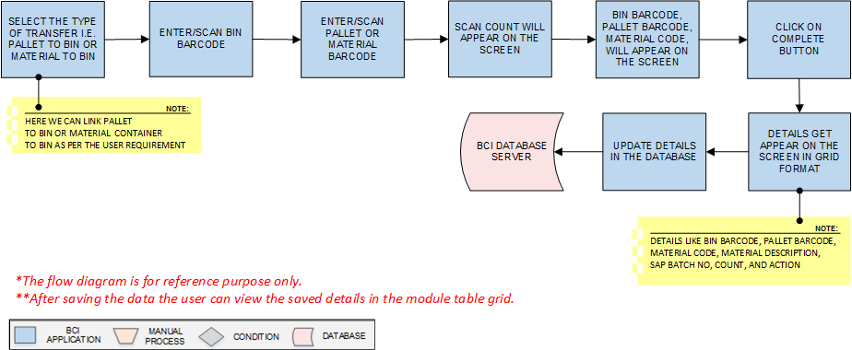
Activities
Module Description | This module will be used to transfer material or pallet from one bin to other.

Pre-Conditions | - Material weights should be captured and labels are applied on each container and containers /Pallets are placed in the BIN.  - Palletization should be completed.

Process Steps | - Select the type of transfer i.e. Pallet to Bin or Material to Bin.  *Here we can link pallet to Bin or Material Container to Bin as per the user requirement  - Enter/Scan Bin Barcode.  - Enter/Scan Pallet or Material Barcode.  - Scan count will appear on the screen.  - Putaway details added successfully.  - A grid format of Bin Barcode and Pallet Barcode will appear on the screen.  - Click on Complete Button.  - A grid format of Bin Barcode, Pallet Barcode, Material Code, Material Description, SAP Batch No, Count, and Action will appear on the screen.  - Data is saved in database.  - Selecting the back/cancel button user can return to the main grid screen from the particular screen without any change.

Post-Conditions | - Material are transferred from one bin to other bin.

Validations | - An alert should be displayed in case duplicate/ invalid Bin Barcode is entered.  - An alert should be displayed in case duplicate/ invalid Pallet Barcode is entered.  - An alert should be displayed in case duplicate/ invalid Material Barcode is entered.  - Allocated material can only be transferred.

GRN Cancellation
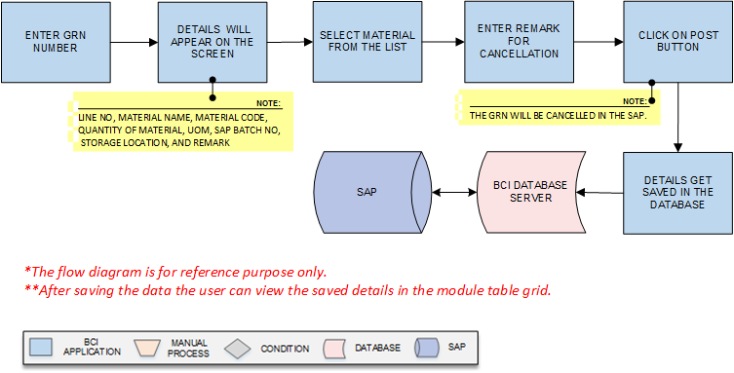
Activities
Module Description | This module will be used to cancel the posted GRN.

Pre-Conditions | - GRN posting is completed.

Process Steps | - Enter/Scan GRN number.  - A grid of Line No, Material Name, Material Code, Quantity of Material, UOM, SAP Batch No, Storage Location, and Remark will appear on the screen.  - Select checkbox of Material from the list.  - Enter Remark for cancellation for the selected material.  - Click on Post button.  *The GRN will be cancelled in the SAP.  - Data is saved in database.

Post-Conditions | - GRN Posting is cancelled.

Validations | - An alert should be displayed in case duplicate/ invalid GRN No is entered.

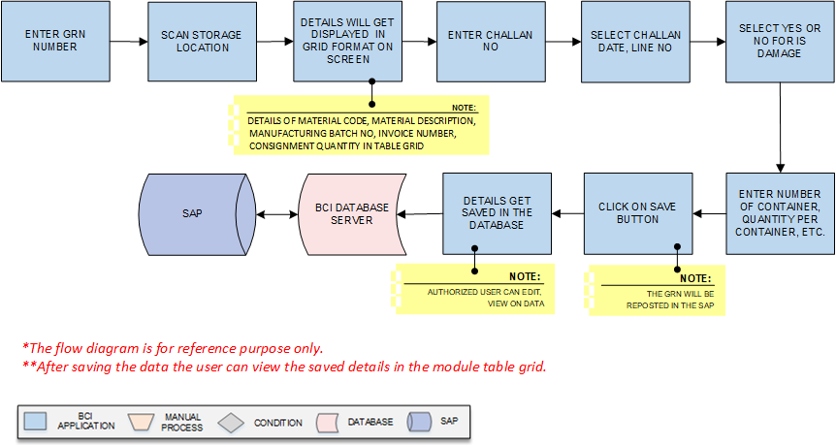
GRN Reposting
Activities
Module Description | This module will be used to repost the cancelled GRN.

Pre-Conditions | - GRN No should be available.

Process Steps | - Enter/Scan GRN number.  - Scan Storage Location.  - A grid format of Material Code, Material Description, Manufacturing Batch No, Invoice Number, Consignment Quantity will be displayed on the screen..  - Enter Challan No in the grid.  - Select Challan Date, Line No in the grid  - Select Yes or No for Is Damage.  - Enter Number of Container, Quantity per Container, Total Quantity Received, Posting Remark.  - Click on Save button.  *The GRN will be reposted in the SAP.  - Click on Close button to close reposting  - Data is saved in database.  *Authorized user can edit, view the data.

Post-Conditions | - GRN is reposted.

Validations | - An alert should be displayed in case duplicate/ invalid GRN No is entered.  - An alert should be displayed in case duplicate/ invalid Storage Location is entered

